Name: ___________________ Teacher: ____Ms Hobson_______

**YEAR 8 Foundation ENGLISH**

**SEMESTER 2 TASK 7: *Jandamarra***

|  |  |  |
| --- | --- | --- |
| **Sub-Strands**  **Literature**  Create literary texts that draw upon text structures and language features of other texts for particular purposes and effects (ACELT1632) | **Literacy**  Apply increasing knowledge of  vocabulary, text structures and  language features to understand the content of texts (ACELY1733) | **Language**  Investigate how visual and multimodal texts allude to or draw on other texts or images to enhance and layer meaning (ACELA1548) |

**Task 2:** Create a 6 panel sequel to *Jandamurra* using graphic novel or picture book conventions.

Students can create a narrative focusing on:

1) how Micki felt after killing Jandamarra and what he did next,

2) a topic of their choice which continues their story,

3) Jandamarra’s journey to the spirit world.

Please hand in the following:

* Your story plan draft
* Draft story with evidence of editing
* Good copy of storyboard

**Assessment will be based on: Reading & Viewing 5%**

|  |  |
| --- | --- |
| **Learning Intentions:** | **What I will do to achieve this success criteria** |
| **skills**  Correct use of graphic novel or picture book conventions to tell a story.  **knowledge**  Demonstrating knowledge and vocabulary of picture book and graphic novel codes and conventions.  **understanding**  How graphic novel codes and conventions contribute to meaning in stories. |  |

**Comments:**

**Assessment Criteria:**

**Writing:**

|  |  |  |  |  |  |
| --- | --- | --- | --- | --- | --- |
|  | **A**  Excellent achievement  80-100 | **B**  High achievement  65-79 | **C**  Satisfactory achievement  50-64 | **D**  Limited achievement  30-49 | **E**  Very low achievement  Less than 29 |
| **Text structure** | Creates an engaging imaginative text that develops own ideas and/or that accurately replicates the language and style of other texts. | Creates an imaginative text that presents own ideas and/or replicates some aspects of the language or style of other texts. | Creates an imaginative text that includes some ideas and language features of other texts. | Creates an imaginative text that presents simplistic ideas based on familiar personal experience and/or the plot of popular texts. | Creates a simple imaginative text based on a popular text such as a television show. |
| **Editing** | Consistently uses a range of editing strategies to demonstrate control over sequencing of ideas, selection of vocabulary, spelling and punctuation. | Monitors and edits own work effectively for accuracy of spelling and punctuation and to achieve specific effects. | Reviews and edits own work to improve paragraphing, vocabulary and/or sentence structure. | Identifies some errors in punctuation or spelling and may attempt to rewrite word or insert punctuation. | May identify basic errors with support. |
| **Spelling** | Consistently spells a range of difficult words correctly. | Correctly spells a range of common and some difficult words. | Correctly spells most common and some difficult words. | Correctly spells some familiar words | Makes frequent spelling errors. |

SCORE:

**Writing: self-assessment checklist** (complete before submission)  **Narrogin SHS** Name__________________________________________________ Year_______ 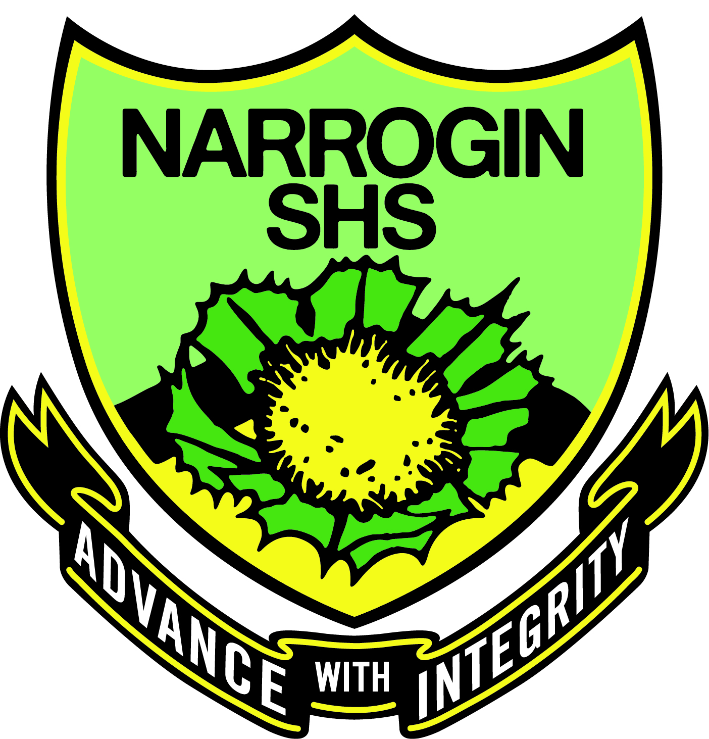

|  |  |  |  |  |
| --- | --- | --- | --- | --- |
| AUDIENCE AND PRESENTATION | PUNCTUATION | CAPITALISATION | SPELLING AND VOCABULARY | IDEAS |
| ⃝ My handwriting is  legible and any typed copies have no typing errors. | ⃝ I have used a full stop at the end of each sentence. | ⃝ I have used capital letters for the first word of each sentence. | ⃝ I have used the dictionary to spell the words I don’t know. | ⃝ I have used brainstorming and planning to organise my ideas. |
| ⃝ I have written the title, my name and the date on my work. | ⃝ I have used commas between words in a list. | ⃝ I have used capitals for proper nouns (the names of people, places and the days of the week). | ⃝ I have used the correct terminology for this topic. | ⃝ I have acted on suggestions from the teacher. |
| ⃝ My sentences are complete, make sense and use the key words from the question. | ⃝ I have used apostrophes to show contraction and possession. | ⃝ I have capitalised the pronoun ‘I’. | ⃝ I have used the correct homophones within my sentences:  your/you’re  there/their/they’re  allowed/aloud | ⃝ Each paragraph only has one main idea. My ideas are in a logical order. |
| ⃝ I have attempted all questions and presented them in the correct order | ⃝ I have used a question mark after a question. | ⃝ I have written the main body of the text using lower case letters. | ⃝ There is evidence of editing on my drafts. | ⃝ I have used linking words to connect my ideas. |

I have carefully checked all of the above before submitting this piece of work.

Signature: _________________________________________ Date: / / 2018

**REFLECTION**

|  |  |  |  |
| --- | --- | --- | --- |
| **What I need to improve on:** | **STRENGTHS:** | **WHAT I ENJOYED:** | **SPELLING WORDS: Write out the correct word three times** |
|  |  |  |  |
| **SELF REFLECTION WITH TEACHER** | **WHAT I DID WELL:** | **AREAS TO WORK ON IN MY NEXT ASSIGNMENT:** | GRAMMAR: Write out the correct grammar rule |
|  |  |  |  |